**Atari ST**

雅达利ST电脑  
Atari ST（系列）

雅达利ST（Atari ST）是一款家用与个人用电脑，在1985年至1990年代早期是非常成功的产品。依雅达利公司的正式说明，ST是英文“Sixteen/Thirty-two”（中文16/32之意），意指摩托罗拉68000处理器的外部16位元与内部32位元的总线。

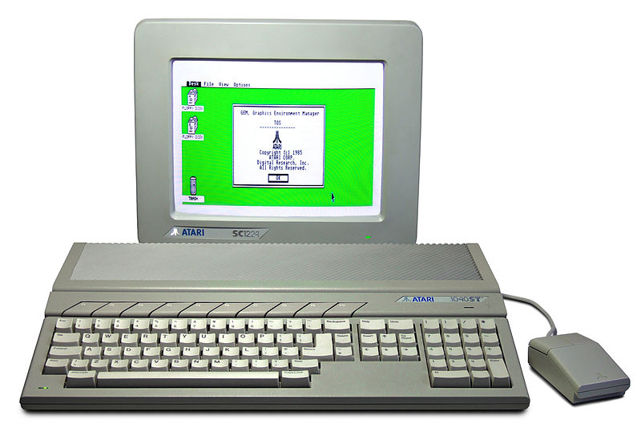

雅达利ST的标准配备除了摩托罗拉68000处理器之外，还有512KB的内存以及3½英吋的软驱，另外还配有一个创新的单芯片绘图系统，使得它成为第一个具有彩色图形使用者接口的电脑。

采用基于数位研究公司的GEMDOS所开发出来的Atari TOS(The Operating System)做为操作系统。

目录

• [主要参数](http://www.techcn.com.cn/index.php?doc-view-140184.html#1)

• [技术规格](http://www.techcn.com.cn/index.php?doc-view-140184.html#3)

• [ATARI 1040ST](http://www.techcn.com.cn/index.php?doc-view-140184.html#5)

• [主要型号](http://www.techcn.com.cn/index.php?doc-view-140184.html#7)

* • [Atari 520ST](http://www.techcn.com.cn/index.php?doc-view-140184.html#9)
* • [电脑游戏的发展史](http://www.techcn.com.cn/index.php?doc-view-140184.html#11)
* • [相关链接](http://www.techcn.com.cn/index.php?doc-view-140184.html#13)
* • [参考文献](http://www.techcn.com.cn/index.php?doc-view-140184.html#15)

主要参数[回目录](http://www.techcn.com.cn/index.php?doc-view-140184.html" \l "section)

类型： 个人电脑   
处理器： 摩托罗拉68000 8MHz   
內存： 512KB 或 1024KB   
操作系统： Atari TOS

Released: January 1985   
Price : US $599   
CPU: Motorola 68000 @ 8MHz   
RAM: 512K   
Display: 320 X 200 - 16 colors   
640 X 200 - 4 colors   
640 X 400 - monochrome   
Ports: RGB, cartridge, parallel, serial, HD   
floppy drive, MIDI (2), joystick, mouse   
Storage: external SSDD 360K floppy drive   
OS: Atari TOS/GEM

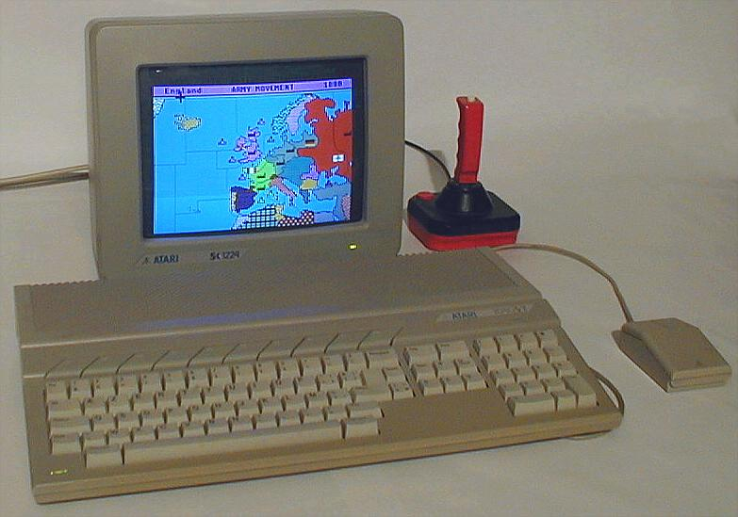

技术规格[回目录](http://www.techcn.com.cn/index.php?doc-view-140184.html" \l "section)

All STs were made up of both custom and commercial chips:

Custom chips   
ST Shifter "Video shift register chip"—Enabled bitmap graphics using 32 KB of contiguous memory for all resolutions. Screen address had to be a multiple of 256.   
ST GLU "Generalized Logic Unit"—Control logic for the system used to connect the ST's chips. Not part of the data path, but needed to bridge chips with each other.   
ST MMU "Memory Management Unit"—Enabled physical memory access up to 4 MB. Maps out the memory space in the ST.   
ST DMA "Direct Memory Access"—Used for floppy and hard drive data transfers. Can directly access main memory in the ST.   
Support chips   
MC6850P ACIA "Asynchronous Common Interface Adapter"—Enabled the ST to directly communicate with MIDI devices and keyboard (2 chips used). 31.25 kBaud for MIDI, 7812.5 bit/s for keyboard.   
MC68901 MFP "Multi Function Peripheral"—Used for interrupt generation/control, serial and misc. control input signals. Atari TT030 had 2 MFP chips.   
WD-1772-PH "Western Digital Floppy Disk Controller"—Floppy controller chip.   
YM2149F PSG "Programmable Sound Generator"—Provided 3-voice sound synthesis, also used for floppy signalling, serial control output and printer parallel port.   
HD6301V1 "Hitachi keyboard processor"—Used for keyboard scanning and mouse/joystick ports.

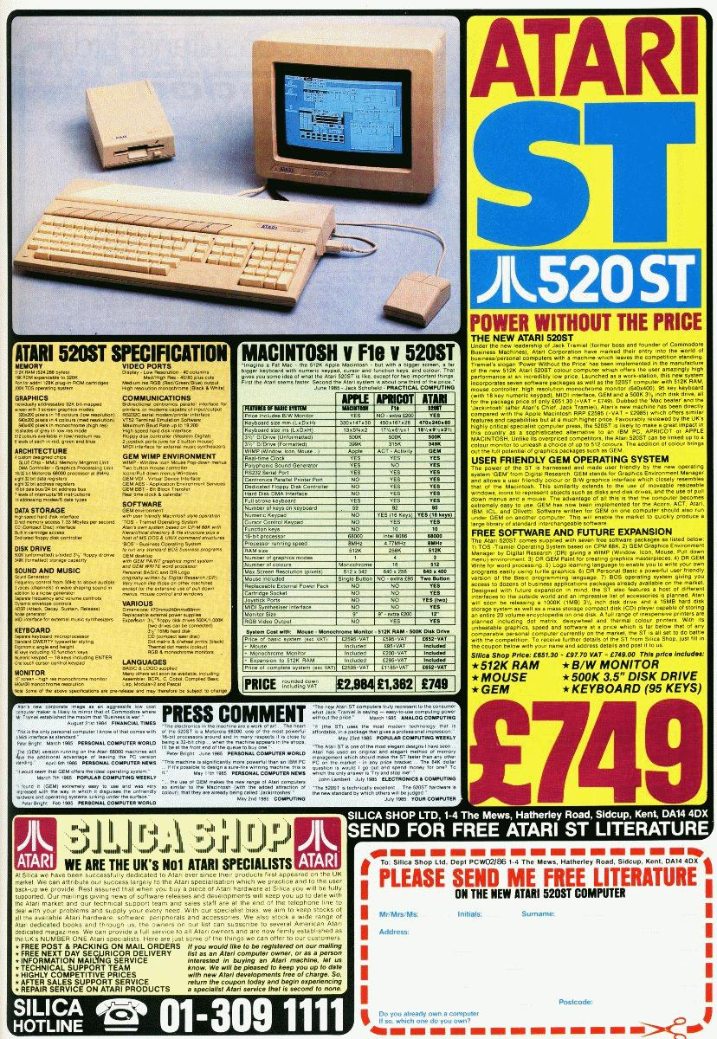

ST/STF/STM/STFM  
As originally released in the 520ST:

CPU: Motorola 68000 16-/32-Bit CPU[20] @ 8 MHz. 16 bit data/32 bit internal/24-bit address.   
RAM: 512 KB or 1 Megabyte   
Display modes (60 Hz NTSC, 50 Hz PAL, 71.2 Hz monochrome):   
Low resolution - 320×200 (16 color), palette of 512 colors   
Medium resolution - 640×200 (4 color), palette of 512 colors   
High resolution - 640×400 (mono), monochrome   
Sound: Yamaha YM2149 3-voice squarewave plus 1-voice white noise mono Programmable Sound Generator   
Drive: Single-sided 3½" floppy disk drive, 360 KB capacity when formatted to standard 9 sector, 80 track layout.   
Ports: TV out (on ST-M and ST-FM models, NTSC or PAL standard RF modulated), MIDI in/out (with 'out-thru'), RS-232 serial, Centronics parallel (printer), monitor (RGB or Composite Video colour and mono, 13-pin DIN), extra disk drive port (15-pin DIN), DMA port (ACSI port, Atari Computer System Interface) for hard disks and Atari Laser Printer (sharing RAM with computer system), joystick and mouse ports (9-pin MSX standard)   
Operating System: TOS v1.00 (The Operating System) with the Graphical Environment Manager (GEM) WIMP (Windows, Icons, Menus, Pointer) GUI

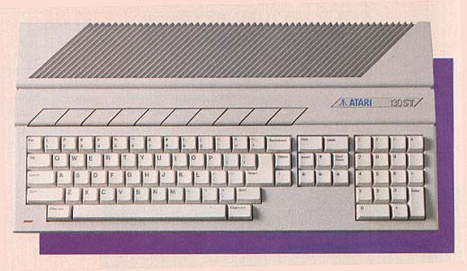

ATARI 1040ST[回目录](http://www.techcn.com.cn/index.php?doc-view-140184.html" \l "section)

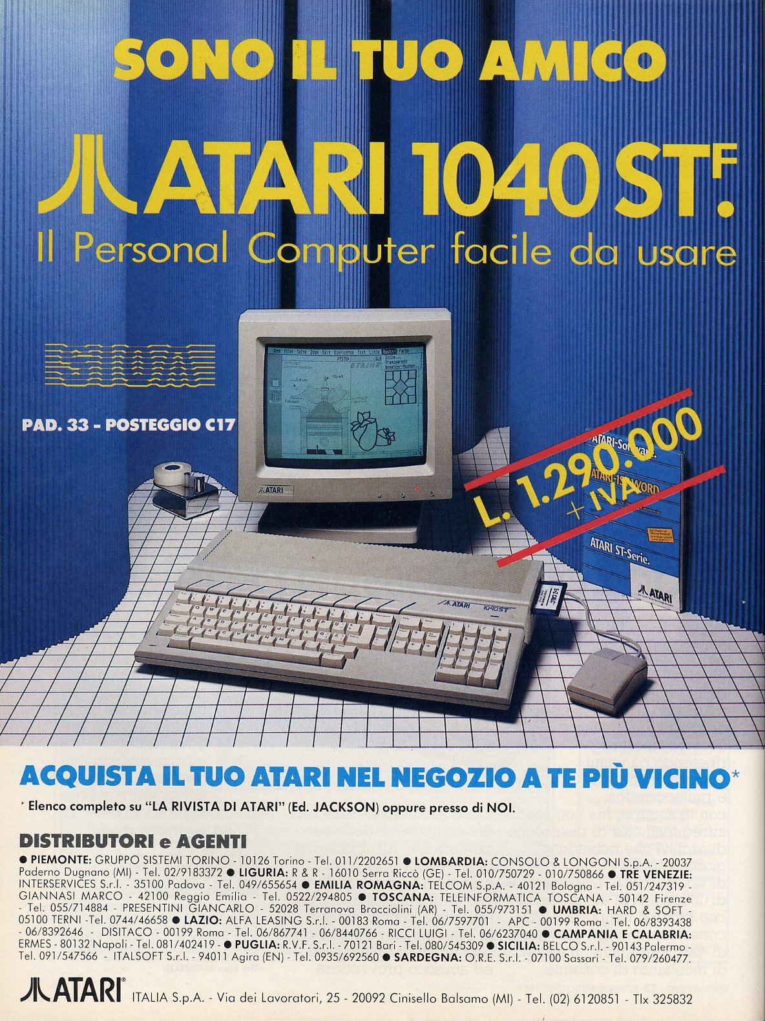

  我自己并没有使用过Atari,因为这款产品在美国并不算是很成功（奇怪的是它在欧洲却能够大放异彩）。Atari ST是在1987发布的，它使用的CPU是 主频为8MHz的Motorola 68000 ，搭配1MB内存，拥有3.5"内置软区，可以使用硬盘和其它附件。因为它具有非常优秀的图形和声音质量，所以它通常被使用在专业的音乐工业领域（主机的右侧有MIDI In/Out 接口）。

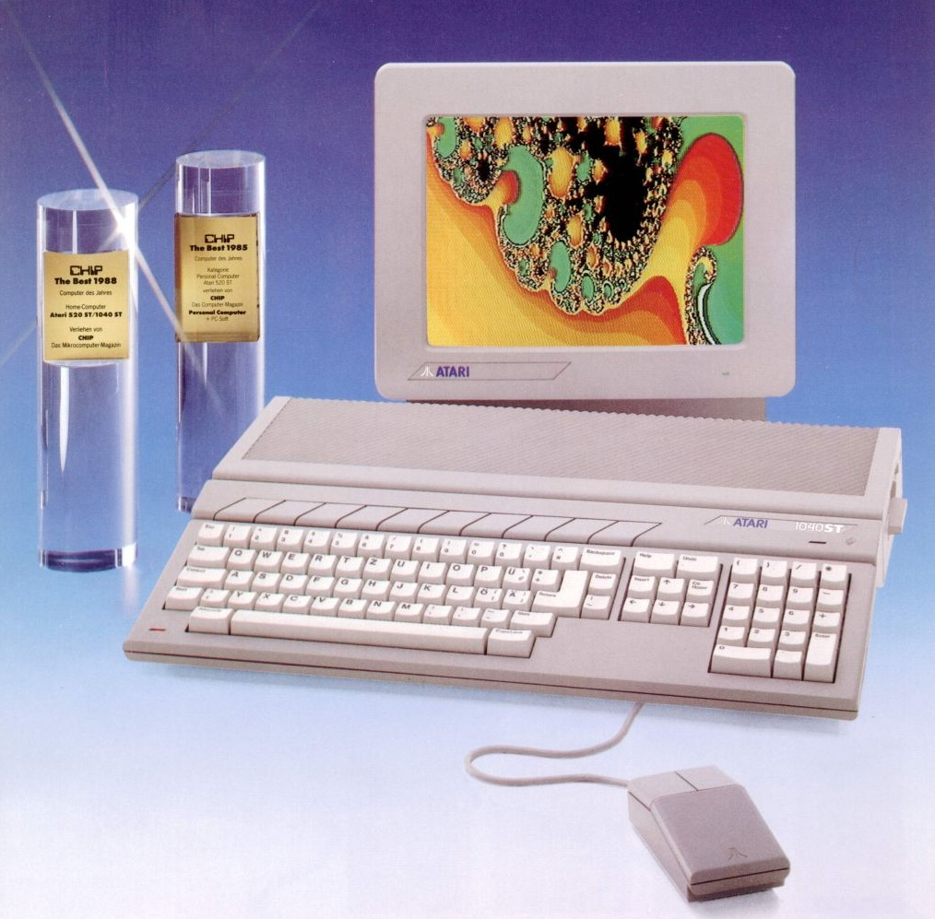

主要型号[回目录](http://www.techcn.com.cn/index.php?doc-view-140184.html" \l "section)

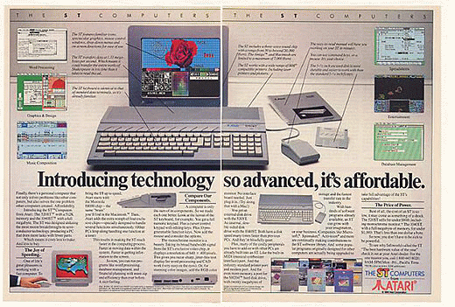

520ST+ - Name for early 520STs with 1 MB of RAM, but without floppy disk   
260ST — European name for the 520ST with 512 KB. Used after the release of the 520ST+ to differentiate the cheaper 512 KB models from the 1 MB models   
520STM - a 520ST with a built-in modulator for TV output   
520STFM - a 520STM with a newly redesigned motherboard in a larger case with a built-in floppy disk drive   
1040STF - a 520STFM with 1 MB of RAM and a built-in double-sided floppy disk, but without RF modulator   
1040STFM - a 520STFM with 1 MB of RAM and a built-in double-sided floppy disk with RF modulator   
Mega ST (MEGA2, MEGA4) - redesigned motherboard with 2 or 4 MB of RAM, respectively, in a much improved "pizza box" case with a detached keyboard. Early models did not include the BLiTTER chip; most did. Included a real-time clock and internal expansion connector.   
520STE and 1040STE - a 520STFM/1040STFM with enhanced sound, the BLiTTER chip, and a 4096-color palette, in the older 1040 style all-in-one case   
4160STE - as 1040STE but with 4 MB of RAM. Never officially released except a small quantity of development units. Labels were sent out to dealers to affix to machines that had been upgraded to 4MB.   
Mega STE - same hardware as 1040STE except for a faster 16 MHz processor, in the TT case   
STacy - A portable (but definitely not laptop) version of the ST. Originally designed to operate on 12 standard C cell flashlight batteries for portability, when Atari finally realized how quickly the machine would use up a set of batteries (especially when rechargeable batteries of the time supplied insufficient power compared to the intended alkalines), they simply glued the lid of the battery compartment shut, and soon discontinued the machine.   
ST BOOK (later version portable ST), vastly more portable than the STacy, but sacrificing several features in order to achieve this — notably the backlight, and internal floppy disc drive. Files were meant to be stored on a small amount (one megabyte) of internal flash memory 'on the road' and transferred using serial or parallel links, memory flashcards or external (and externally powered) floppy disc to a 'real' desktop ST once back indoors. The screen is highly reflective for the time, but still hard to use indoors or in low light (the idea of a switchable green LED backlight seeming not to have inspired the Atari technical department as it did many wristwatch manufacturers), it is fixed to the 640x400 1-bit mono mode (not even greyscale emulation of colour in low res is offered), and no external video port was provided. For its limitations, it gained some popularity as being the most utterly portable 'real' computer of the day (slim, light, quiet, reliable, and with a long battery life, even by today's standards for all 5), particularly amongst musicians already used to using the original computer and perhaps having lugged a STacy or even a full ST + Monitor + accessories rig on tour.

Atari 520ST[回目录](http://www.techcn.com.cn/index.php?doc-view-140184.html" \l "section)

|  |  |
| --- | --- |
|  |  |

|  |  |
| --- | --- |
| **NAME** | 520 ST / ST+ / STM |
| **MANUFACTURER** | Atari |
| **TYPE** | Home Computer |
| **ORIGIN** | U.S.A. |
| **YEAR** | 1985 |
| **KEYBOARD** | Full-stroke keyboard with numeric and editing keypads |
| **CPU** | Motorola MC68000 |
| **SPEED** | 8 mHz |
| **CO-PROCESSOR** | 'Shifter' and 'Glue' custom chips |
| **RAM** | 512 KB (520 ST/STM), 1 MB (520 ST+) |
| **ROM** | 192 KB |
| **TEXT MODES** | 40 or 80 columns x 25 lines |
| **GRAPHIC MODES** | 320 x 200 / 640 x 200 / 640 x 400 dots |
| **COLORS** | 16 among 512 (320 x 200) / 4 among 512 (640 x 200) / monochrome (640 x 400) this last mode needs a special monitor. |
| **SOUND** | 3 voices, 8 octaves |
| **SIZE / WEIGHT** | 47 (W) x 24 (D) x 6 (H) cm |
| **I/O PORTS** | RGB, TV modulator (520STm), Cardridge, Midi (in/out), Centronics, RS232c, Hard Disk, Floppy Disk, Joystick, Mouse |
| **BUILT IN MEDIA** | External 3.5'' 360 KB disk-drive (option) |
| **OS** | TOS / GEM |
| **POWER SUPPLY** | External power supply unit |
| **PRICE** | ?49 (1985, UK), ?99 (1986, UK) |

|  |
| --- |
| http://www.techcn.com.cn/uploads/201001/1262589986k1Vl7mzX.jpg   http://www.techcn.com.cn/uploads/201001/1262589986IBvOFKcI.jpg |

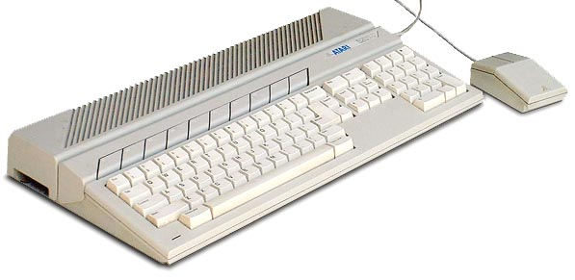  
The Atari 520ST was introduced at the Winter CES in January of 1985, 6 months before the [Commodore Amiga](http://oldcomputers.net/amiga1000.html). Atari did take some shortcuts, though, as the Operating System did not yet exist in ROM, and had to be loaded from floppy-disk when powered on (but then again, so did the Amiga). The 520ST also had no internal floppy drive, but later versions included it.   
  
Bundled with an external 360K single sided 3.5 inch floppy drive, mouse and monochrome monitor, it costs $799.   
Both Amiga and 520ST are based on the Motorola 68000 CPU, which has a 16-bit external bus, and 32-bit internal, thus the 520'ST' means 'sixteen / thirty two'. The Operating System is 'TOS', or 'Tramiel Operating System'.   
  
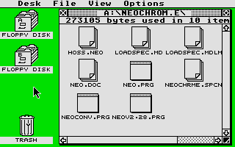  
The 520ST (and Amiga) have a graphical operating system, or GUI, similar to the Apple Macintosh, which was released one year earlier. The 520ST utilized Digital Research's GEM GUI, although it is not nearly as nice as the Macintosh or Amiga.   
  
One thing that IS very nice is the built-in VT52 emulation. The 520ST can act as a dumb terminal, communicating through its serial port to another system.   
  
There was a huge rivalry between Amiga and Atari users, each positive that their computer system was superior, or at least hoping it was.   
  
In addition to the 520ST, Atari release the 1040ST, with built-in floppy drive, and 1Meg of RAM (the 520ST has 512K). Four years later in 1989, the portable ST computer appeared, the Stacy.

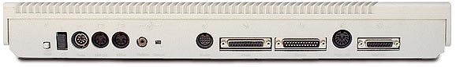

电脑游戏的发展史 [回目录](http://www.techcn.com.cn/index.php?doc-view-140184.html" \l "section)

60年代早期

使用最原始的大型计算机，一小部分程序员开发游戏而其他人认为他们在做研究。在MIT的实验室里开发了Space War和其它早期的游戏。

1973年到1975年

Nolan Bushnell建立了Syxygy。在市场上出售SpaceWar的“Arcade”版，但失败了。在1975年下半年，推出了Pong，并使之成为一个非常流行的游戏，之后，他重新命名公司为Atarh他们始创了我们今天所熟知的游戏工业。

1960年后期到1970年早期

更多的程序员使用大型计算机开发游戏；WilliamCrowther开发了流行游戏Adventure。

1976年

Rushnell以＄2，600万将Atari出售给WarnerCommunications。

1980年其它游戏系统依次登台，象Pllillins的Oddessy和Mattel的Intellivision，目标都是希望取代Atari。一些小的个人计算机开始出现，但视频游戏仍处于领先位置。

1977年

Atari推出了Atari2600VCS，家庭视频游戏行业兴起！一个名叫Apple的小公司出售一种计算机Apple l，但没能引起人们的注意。

1979年

Atari公司的一些项尖的程序开发员从对Atari的意见不一致发展到公开的不满，成立了自己的公司Activision，其它“第三方”开发公司相应出现。

1981年

IBM推出了IBM PC。

1982年

Atari开始滑坡，视频游戏市场处于大萧条状态。Atari的主席Ray Kassar宣布销售已下跌了50％。个人计算机应时出现，许多新型计算机游戏开发者纷纷出现，其中有些成为了专业开发队伍，新出现的知名公司包括Sierra On－Line 、 Broder－bund、Synapse、Sirius及Strategic Simulations。

Electronic Arts成立，并成为现代游戏公司的楷模。

1984年

Apple推出新型计算机产品Macintosh，但该系统缺点是启动馒，此时该系统的购买者和软件开发者的主要目的不是开发游戏。

1983年伟大的视频游戏跌至最低点，Mattel宣布其Intellivision产品损失＄22，500万。



1985年

Nintendo由于投入一种新的视频游戏产品—任天堂娱乐系统，而重新繁荣了家庭视膝游戏市场。16位的计算机的革命继续，Atari的产品Atari ST投入市场是对CommodOre一个沉重的打击。

1986年

CommodOre极力宣传并推出Amiga计算机，该计算机是由Atari硬件设计师Jay Miner设计的，最初是想作为下一代的视频游戏系统，但由Commodore投资的这种机型却成为机器Commodore64的继承者。不幸的是，巨大的市场打击和其它的开发埋没了该系统的远大前程。

Sega推出了Sega Master系统，在技术上要优于Nintendo Enter。tainment系统。由于Sega忽视第三方开发者，没有征集足够多的软件支持该系统，所以没有取得足够大的市场支持而失败。

1988年

计算机行业从8位计算机转向16位系统，新出现的视频游戏控制台引起了新的合并，Cine。maware、Epyx等公司处于困难时期。

1987年

游戏变得更复杂了，更多的公司转向集体开发，Electronic Arts推出了第一个集体开发产品“Skate or Die1"

IBM PC系列，由于具有了好的图形适配器，开始成为可采用的计算机游戏平台。

1989年

新的16位系统初次登台，最值得注意的是Sega的Genesis。当Sega由于广告宣传和大量的EA运动游戏，占据控制台市场的领先地位时，任天堂（Nintendo）觉悟已晚，损失惨重。

1990年

Amiga和ST在市场上基本灭迹，PC系列和控制台成为主要的游戏开发平台。Electromc Arts开始成为主要的游戏开发和发行者。

1992年

PC游戏开始流行，在它迅速发展的几年里，其它一些计算机游戏平台被淘汰，把PC游戏市场推向一个新高度。

1991年

Nintendo的产品Super一NES首次推向市场，16位之战的全面爆发促进了许多控制台系统的销售。

1993年Pentium芯片出现，Microsoft预先展示了它的新产品Windows操作系统，代码名为Chicago。尽管PC迅速发展，Sega和Ninter1do继续处于领先位置，控制台系统占领了世界游戏市场的80％。

1994年

Panasonic推出了Real－3Do游戏机，预示着32位控制台系统的出现。

Atati推出Jaguar 32位游戏机。但这两个产品（尤其是3DO）都不很成功。

Id Software推出了Doom，使人们意识到可以使用共享软件发行方法。

1995年

Sega生产了Sega 32位控制台系统。Sony推出了Sony Playstation 32位控制台系统。

Microsoft推出了Windows 95和windows Game SDK，使得大量的游戏开发转向Windows乎台。

Internet和Word Wide Web流行，大量的用户上网。

1996年

Nintendo推出了UItra64。大范围的多人游戏已经出现。多媒体、3D和虚拟现实等取代WWW而成为热点，主要的新技术和产品包括Java 1 ShockWare、Javaｓｃｒｉｐｔ、Netscape 2等等。

1997年至今

Iintel推出MMX技术，并基于此推出Pentium MMX和PentiumⅡ处理器。AMD和Cyrix也基于MMX技术推出了K6和M2处理器。游戏开始大量使用MMX技术。PC与其他的控制台系统在性能上已相差不大了。

AMD推出3D-NOW技术，使其基于3D-NOW的处理器K6-3D在图象处理的方面超过PentiumⅡ。

相关链接[回目录](http://www.techcn.com.cn/index.php?doc-view-140184.html" \l "section)

• [520ST review](http://www.atarimagazines.com/creative/v11n10/26_Atari_520ST_a_reborn_Ata.php) from [Classic Computer Magazine Archive](http://www.atarimagazines.com/)

• [520ST](http://www.myoldcomputers.com/museum/comp/520st.htm) from ["myoldcomputers.com"](http://www.myoldcomputers.com/)

• [520ST](http://www.sothius.com/hypertxt/welcome.html?520stplus.html) from [Sothius' Home of Ancient Microcomputers](http://www.sothius.com/hypertxt/welcome.html)

• Get your Ataris from [Best Electronics](http://www.best-electronics-ca.com/)

• [520ST](http://en.wikipedia.org/wiki/Atari_ST) from Wikipedia

参考文献[回目录](http://www.techcn.com.cn/index.php?doc-view-140184.html" \l "section)

<http://en.wikipedia.org/wiki/Atari_ST>  
http://www.old-computers.com/museum/computer.asp?st=1&c=20